**PROJECT REPORT ON**

**Smart Farmer - IoT Enabled Smart Farming Application**

**TEAM ID:** PNT2022TMID26547

# TEAM MEMBERS:

R.Guru Murugan

C.DineshKumar

V.Naveen

G.MuthuRaj

# INDEX

## INTRODUCTION

* 1. Project Overview
  2. Purpose

## LITERATURE SURVEY

* 1. Existing problem
  2. References
  3. Problem Statement Definition

## IDEATION & PROPOSED SOLUTION

* 1. Empathy Map Canvas
  2. Ideation & Brainstorming
  3. Proposed Solution
  4. Problem Solution fit

## REQUIREMENT ANALYSIS

* 1. Functional requirement
  2. Non-Functional requirements

## PROJECT DESIGN

* 1. Data Flow Diagrams
  2. Solution & TechnicalArchitecture
  3. User Stories

## PROJECT PLANNING &SCHEDULING

* 1. Sprint Planning & Estimation
  2. Sprint Delivery Schedule

## CODING & SOLUTIONING (Explain the features-added in the project along with code)

* 1. Feature 1

## TESTING

* 1. Test Cases
  2. User Acceptance Testing

## RESULTS

* 1. Performance Metrics

## ADVANTAGES & DISADVANTAGES

1. **CONCLUSION**

## FUTURE SCOPE

1. **APPENDIX**

Source Code

GitHub & Project Demo Link

**SmartFarmer - IoT Enabled Smart Farming Application**

**INTRODUCTION**

In this project, we are going to build a **Smart Farming System using IoT**. The objective of this project is to offer assistance to farmers in getting Live Data (Temperature, Humidity, Soil Moisture, Soil Temperature) for efficient environment monitoring which will enable them to increase their overall yield and quality of products. This smart agriculture using IoT system powered by NodeMCU consists of a DHT11 sensor, Moisture sensor, DS18B20 Sensor Probe, LDR, Water Pump, and 12V led strip. When the IoT-based agriculture monitoring system starts, it checks the Soil moisture, temperature, humidity, and soil temperature. It then sends this data to the IoT cloud for live monitoring. If the soil moisture goes below a certain level, it automatically starts the water pump. We previously build Automatic Plant Irrigation System which sends alerts on mobile but doesn’t monitor other parameters. Apart from this, Rain alarm and soil moisture detector circuit can also be helpful in building Smart Agriculture Monitoring System.

The Internet of things (**IoT**) describes physical objects (or groups of such objects) with sensors, processing ability, software and other technologies that connect and exchange data with other devices and systems over the Internet or other communications networks.Internet of things has been considered a misnomer because devices do not need to be connected to the public internet, they only need to be connected to a network and be individually addressable.

Even though modern agriculture is already heavily automated. There is still a lot of room for improvement in terms of productivity and predictability. Nowadays, pests, droughts and the consequences of climate change wreak unprecedented havoc on farmers across the globe. Data-driven solutions using IoT devices are able to provide useful insights that can be used to predict such dangers. Even if the next harvest is at no particular risk, IoT-devices will still help to increase overall efficiency by reducing costs and allocating resources (such as water, fertilizers and pesticides) to where they are truly needed.

**PROJECT OVERVIEW**

The Internet of Things is a developing theme of specialized, social, and monetary centrality. Customer items, tough goods, cars and trucks, modern and utility segments, sensors, and other regular articles are being joined with Internet availability and amazing information systematic capacities that guarantee to change the manner in which we work, live, and play. Projections for the effect of IoT on the Internet and economy are amazing, with some foreseeing upwards of 100 billion associated IoT gadgets and a worldwide financial effect of more than $11 trillion by 2025. The Internet of Things (IoT) is an essential theme in innovation industry, strategy, and designing circles [1]. This innovation is encapsulated in a wide range of arranged items, frameworks, and sensors, which exploit headway s in processing power, gadgets scaling down, and organize interconnections to offer new capacities. The expansive scale usage of IoT gadgets guarantees to change numerous parts of the manner in which we live. For shoppers, new IoT items like Internet-empowered machines, home mechanization parts, and vitality the executive’s gadgets are pushing us toward a dream of the "savvy home'', offering greater security and vitality effectiveness. IoT frameworks like arranged vehicles, savvy traffic frameworks, and sensors implanted in streets and scaffolds draw us nearer to "brilliant urban areas'', which help limit clog and vitality utilization. IoT innovation offers the likelihood to change horticulture, industry, and vitality creation and dissemination by expanding the accessibility of International Journal of Scientific Research in Science and Technology (www.ijsrst.com) Sayali Joshi et al. Int J Sci Res Sci Technol. March-April-2019; 6(2) : 445-450 446 data along the esteem chain of generation utilizing arranged sensors [3]. II. METHODS AND MATERIAL System: Input, Output, Function, Success, Failure Input: Sensor data signal which is not regular or Change in Signal Output: End User get informed with alert buzzer and Display to LCD Functions: 1. Access ():- In this module we are going to access the feature provided by the module which Will include Sensor data access. 2. Control ():-In this module we are controlling the Alert System by using System which is connected to hardware or sensor data. 3. Broadcast ():-In this module we are going to broadcast the alert Display to LCD. 4. Success Conditions: 1. If such data which is received through sensors are not stable or are more than threshold it will predict that there is leakage situation 5. Failure Conditions: Desired output is not generated due to following failures. 1. Software Failure 2. Hardware Failure 3. Network Connection Failure HARDWARE INFORMATION: 1. Arduino Uno The Arduino Uno is a micro controller board based on the ATmega328 (datasheet). It has 14 digital input/output pins (of which 6 can be used as PWM outputs), 6 analog inputs, a 16 MHz ceramic resonator, a USB connection, a power jack, an ICSP header, and a reset button. It contains everything needed to support the micro controller; simply connect it to a computer with a USB cable or power it with a AC-to-DC adapter or battery to get started. The Uno differs from all preceding boards in that it does not use the FTDI USB-to-serial driver chip. Instead, it features the Atmega16U2 (Atmega8U2 up to version R2) programmed as a USB-to-serial converter. 2. LCD (Liquid Crystal Display) LCD stands for Liquid Crystal Display. LCD is finding wide spread use replacing LEDs (seven segment LEDs or other multi segment LEDs) because of the following reasons: 1. The declining prices of LCDs. 2. The ability to display numbers, characters and graphics. This is in contrast to LEDs, which are limited to numbers and a few characters. 3. Incorporation of a refreshing controller into the LCD, thereby relieving the CPU of the task of refreshing the LCD. In contrast, the LED must be refreshed by the CPU to keep displaying the data. 3. BUZZER A buzzer or beeper is an audio signalling device, which may be mechanical, electro mechanical, or piezoelectric. Typical uses of buzzers and beepers include alarm devices, timers and confirmation of user input such as a mouse click or keystroke. The first electric buzzer was invented in 1831 by Joseph Henry. They were mainly used in early doorbells until they were phased out in the early 1930s in favor of musical chimes, which had a softer tone. Piezoelectric buzzers, or piezo buzzers, as they are sometimes called, were invented by Japanese manufacturers and fitted into a wide array of products during the 1970s to 1980s. This advancement mainly came about because of cooperative efforts by Japanese manufacturing companies. In 1951, they established the Barium Titanate Application Research Committee, which allowed the companies to be "competitively International Journal of Scientific Research in Science and Technology (www.ijsrst.com) Sayali Joshi et al. Int J Sci Res Sci Technol. March-April-2019; 6(2) : 445-450 447 cooperative" and bring about several piezoelectric innovations and inventions. 4. Bluetooth Module: SIM900 GSM Module – This means the module supports communication in 900MHz band. We are from India and most of the mobile network providers in this country operate in the 900MHz band. If you are from another country, you have to check the mobile network band in your area. A majority of United States mobile networks operate in 850MHz band (the band is either 850MHz or 1900MHz). Canada operates primarily on 1900 MHz band.

**2.Literature Survey**

**Existing Problem:**

* A unified solution which can be integrated with different types of Internet of Things devices.
* The most common challenge for the Internet of Things in agriculture is connectivity. Every area doesn’t have proper internet connectivity.
* The second most common challenge for Internet of Things based Advanced Farming is the lack of awareness among consumers.
* Due to various service providers, it becomes really difficult to maintain interoperability between different IoT systems.
* A scalable solution that can be integrated with thousands of IoT devices for large farms.

**REFERENCE**

1. "Technology and digital in agriculture - OECD". *www.oecd.org*. Retrieved 2019-07-25.
2. Jump up to:***a*** ***b*** Trendov, Nikola M.; Varas, Samuel; Zeng, Meng. "Digital Technologies in Agriculture and Rural Areas" (PDF). Retrieved 17 October 2021.
3. "Digital Agriculture: feeding the future". *Project Breakthrough*. Retrieved 2019-07-25.
4. "Digital Agriculture | Cornell University Agricultural Experiment Station". *cuaes.cals.cornell.edu*. Retrieved 2019-07-25.
5. "Home". *Purdue University Digital Agriculture*. Retrieved 2019-07-25.
6. Jump up to:***a***Shepherd, Turner, Small, and Wheeler (2018). "Priorities for science to overcome hurdles thwarting the full promise of the 'digital agriculture' revolution". *Journal of the Science of Food and Agriculture*. **100** (14): 5083–5092. doi:10.1002/jsfa.9346. PMC 7586842. PMID 30191570.
7. **^**Rose, David Christian; Chilvers, Jason (2018). "Agriculture 4.0: Broadening Responsible Innovation in an Era of Smart Farming". *Frontiers in Sustainable Food Systems*. doi:10.3389/fsufs.2018.00087.
8. Schwab, Karl (2018). *The Fourth Industrial Revolution*. Crown Publishing Group.
9. Schwab 2018. *The Fourth Industrial Revolution*. Encyclopedia Britannica. https://www.britannica.com/topic/The-Fourth-Industrial-Revolution-2119734.
10. **^** Allen, Robert C. (1999). "Tracking the agricultural revolution in England". *The Economic History Review*. **52** (2): 209–235. doi:10.1111/1468-0289.00123.

**PROBLEM STATEMENTS**

The traditional agriculture and allied sector cannot meet the requirements of modern agriculture which requires high-yield, high quality and efficient output. Thus, it is very important to turn towards modernization of existing methods and using the information technology and data over a certain period to predict the best possible productivity and crop suitable on the very particular land. The adoptions of access to high-speed internet, mobile devices, and reliable, low-cost satellites (for imagery and positioning) are few key technologies characterizing the precision agriculture trend. Precision agriculture is one of the most famous applications of IoT in the agricultural sector and numerous organizations are leveraging this technique around the world. Some products and services in use are VRI optimization, soil moisture probes, virtual optimizer PRO, and so on. VRI (Variable Rate Irrigation) optimization maximizes profitability on irrigated crop fields with topography or soil variability, improve yields, and increases water use efficiency. IoT has been making deep inroads into sectors such as manufacturing, health-care and automotive. When it comes to food production, transport and storage, it offers a breadth of options that can improve India’s per capita food availability. Sensors that offer information on soil nutrient status, pest infestation, moisture conditions etc. which can be used to improve crop yields over time. Some of the sample problem statements related to Agriculture & allied sectors where IoT application will be beneficial are given.

**3.Ideation**

**Empathy map**

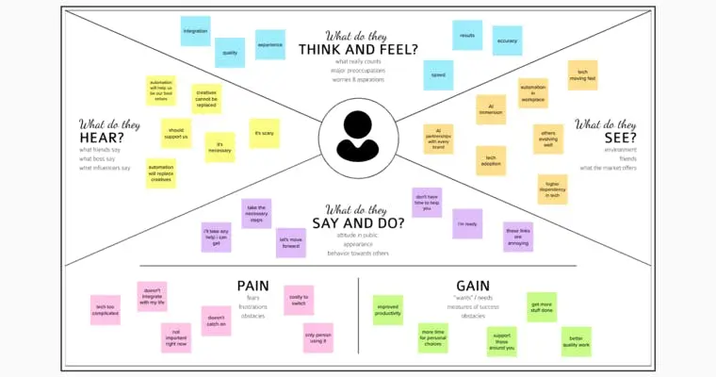

**Ideation and Brainstorming**

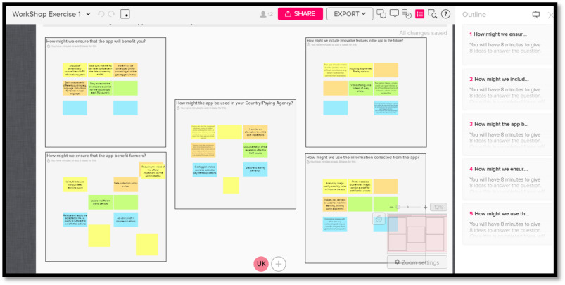

**Problem Solution Fit**

Problem solution fit p pg. 1 Smart farming has enabled farmers to reduce waste and enhance productivity with the help of sensors(light, humidity, temperature, soil, moisture, etc.,) and automation of irrigation systems. Further with the help of these sensors, farmers can monitor the field conditions from anywhere. Internet of things based advanced farming is highly efficient when compared with the conventional approach. The applications of intelligent agriculture solutions not only targets conventional, large farming. With operations, but could also be new levers to uplift other growing or common trends in agriculture Agri Bot-Autonomous Tractor Tractors are essential agriculture equipment that is used right from preparing the soil for planting seed all the way to harvesting crops agribot develops its eponymous autonomous tractor the agribot offering several benefits for the formers apart from saving time their tractors are fitted with a range of sensors to significantly reduce human contact with chemicals and pesticides during weeding. It allows for increased capacity, working day and night along with the ability to carry out two agronomic tasks simultaneously. One water-smart irrigation The changing seasons have a great impact on agricultural activities. Indian stat up one water, guided by their parent company nascent info technologies, develops internet of things(IoT) based smart irrigation systems for agriculture. Excess water can also cause the destruction of crops and spur the growth of weeds. One water can sense soil moisture, humidity, and temperature to automatically execute drip irrigation on the farm, saving valuable resources . Saga robotics-autonomous harvesting Automation in harvest technologies for agriculture ensures lower stress on labour from potential accidents or snake-bites. Norwegian start up saga robotics develops a modular robotic platform called Thorvald, an autonomous farm robot capable of performing several tasks, including harvest of fruits and vegetables Desamis-livestock monitoring Cattle, sheep, pigs, goats, and chicken contribute significantly to food and clothing for humans. Animal husbandry is an important branch of agriculture that deals with the day-to-day caring, breeding, raising, and monitoring of livestock. Cattle, especially, are being provided with their own sensors that track their movement and activity, monitor heat in their stomach, check their breath to detect diseases, and more. Plastomics-genetic editing It is believed that by 2050, there will be around 9 billion humans in the world. Today, almost all arable land in the world is being used for agriculture. This drives innovation in agriculture to significantly increase farm output or yield per acre/hectare. And one of the most powerful, but controversial, innovations is the genetic manipulation of crop seeds. Problem solution.

**Proposed Solution**

The Problem-Solution Fit canvas is based on the principles of Lean Startup, LUM (Lazy User Model) and User Experience design. It helps entrepreneurs, marketers and corporate innovators identify behavioral patterns and recognize what would work and why. It is a template to help identify solutions with higher chances of solution adoption, reduce time spent on testing and get a better overview of the current situation.My goal was to create a tool that translates a problem into a solution, taking into account customer behavior and the context around it. None of the existing canvases or frameworks were giving me an overview and insight into the real customer situation during his/her decision-making process. With this template you will be able to take important information into consideration at an earlier stage and look at problem solving in depth. It increases your chances of finding problem-solution and product-market fit.

**4.Requirement Analysis**

**Functional and Non Functional Requirements**

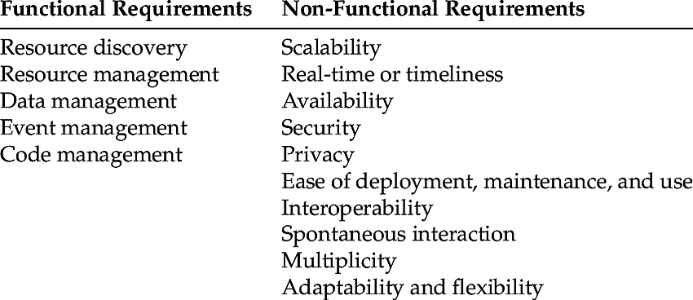

**5.Project Design**

**Data Flow Diagram**

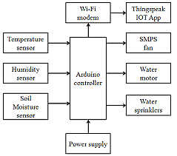

**Solution and Technical Architecture**

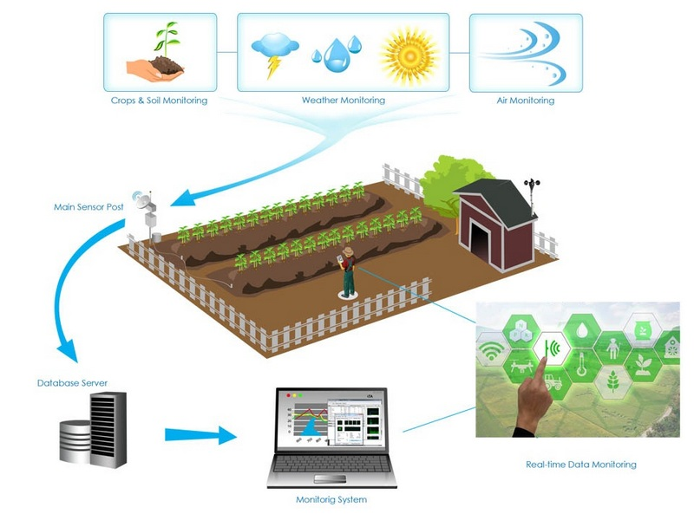

**User Stories**

Multiple models of design thinking have emerged over the years, however, the roots of the approach date back to Professor John Arnold (1913–1963) who was famous for making his engineering students at MIT imagine that they were designing products for someone from outer space instead of for their peers (who always liked their design). In 1957, Arnold went to Stanford University where he built up the engineering design school. One of his students, David Kelley, later founded the now world leading design firm IDEO, as well as the D.school at Stanford University. Kelley's Stanford model of Design Thinking consists of 5 key phases: (i) Empathise; (ii) Define; (iii) Ideate; (iv) Prototype and (v) Test (Kelley, 2001). The first three phases will represent the focus of the current paper, up to the point of first prototype development of the technology. These are the most pivotal stages of the design process in which the technology is created and defined, and where the unique value of multi-actor engagement is established. The first phase, *empathize,* focuses on gaining an understanding of users' needs and challenges through interviews and/or observation. Gaining insight into a user's emotions, aspirations, and fears can provide designers with critical cues and inspiration to create a more balanced and functional product, which meets the users' needs.

**7.Coding and Solutioning**

**Feature-1**

Support up to 5*5*2 Keypads.  
• One full function UART port, and can be configured to two independent serial ports.  
• One USB port can be used as debugging and firmware upgrading.  
• Audio channels which include a microphone input and a receiver output.  
• Programmable general-purpose input and output.  
• One SIM card interface.  
• Support Bluetooth function.  
• Support one PWM.  
• PCM/SPI/SD card interface, only one function can be accessed synchronously.  
• Power supply 3.4V ~ 4.4V  
• Typical power consumption in sleep mode is 1.2mA  
• Frequency bands GPRS multi-slot class 12  
• Support SIM card: 1.8V, 3V

• Serial Port: Can be used for AT commands for data stream  
• USB Port: Can be used as debugging and firmware upgrading

**Feature-2**

include libraries

#include <dht.h>

#include <SoftwareSerial.h>

//define pins

#define dht_apin A0 // Analog Pin sensor is connected SoftwareSerial mySerial(7,8);//serial port of gsm const int sensor_pin = A1; // Soil moisture sensor O/P pin int pin_out = 9; //allocate variables dht DHT;

int c=0;

void setup()

{

pinMode(2, INPUT); //Pin 2 as INPUT pinMode(3, OUTPUT); //PIN 3 as OUTPUT

pinMode(9, OUTPUT);//output for pump

}

void loop()

{

if (digitalRead(2) == HIGH)

{

digitalWrite(3, HIGH); // turn the LED/Buzz ON delay(10000); // wait for 100 msecond digitalWrite(3, LOW); // turn the LED/Buzz OFF delay(100);

}

Serial.begin(9600);

delay(1000);

DHT.read11(dht_apin); //temprature float h=DHT.humidity; float t=DHT.temperature;

delay(5000); Serial.begin(9600);

float moisture_percentage;//moisture int sensor_analog;

sensor_analog = analogRead(sensor_pin);

moisture_percentage = ( 100 - ( (sensor_analog/1023.00) * 100 ) ); float m=moisture_percentage;

delay(1000);

if(m<40)//pump

{

while(m<40)

{

digitalWrite(pin_out,HIGH);//open pump sensor_analog = analogRead(sensor_pin);

moisture_percentage = ( 100 - ( (sensor_analog/1023.00) * 100 ) ); m=moisture_percentage;

delay(1000);

}

digitalWrite(pin_out,LOW);//closepump

}

if(c>=0)

{

mySerial.begin(9600); delay(15000); Serial.begin(9600); delay(1000); Serial.print("\r");

delay(1000);

Serial.print("AT+CMGF=1\r"); delay(1000);

Serial.print("AT+CMGS=\"+XXXXXXXXXX\"\r"); //replace X with 10 digit mobile e number delay(1000);

Serial.print((String)"update-

>"+(String)"Temprature="+t+(String)"Humidity="+h+(String)"Moisture="+m); delay(1000); Serial.write(0x1A); delay(1000);

mySerial.println("AT+CMGF=1");//Sets the GSM Module in Text Mode delay(1000);

mySerial.println("AT+CMGS=\"+XXXXXXXXXX\"\r"); //replace X with 10 digit

mobile number delay(1000);

mySerial.println((String)"update-

>"+(String)"Temprature="+t+(String)"Humidity="+h+(String)"Moisture="+m);// message format

mySerial.println(); delay(100); Serial.write(0x1A); delay(1000);

c++;

}

}

**DataBase System**

**8.Testing**

**Testing of Cases**

Most industries use the manual sorting process to sort consumer goods production. The problem of manual sorting is taking a long time to complete the work. The industry should be demanded to be faster and more efficient in meeting consumer needs. The purpose of this research is to make a tool that can sort goods automatically into the warehouse using RFID technology by combining Arduino and PLC as the controller. The number of items that have been sorted can be monitored remotely by using the Internet of Things (IoT). By identifying the items using RFID makes work more concise and efficient. This research uses an experimental method. The automatic sorting system uses an RFID reader to read ID cards that have been installed on the goods side. The ID cards are processed into Mod bus data to be sent to the PLC Siemens S7-1200 via Ethernet Shield that is connected to the Arduino Mega 2560. The PLC will select items to be placed on each conveyor. The results of this study showed that the system can work automatically in the sorting of consumer goods and can monitor the process of its work system on the GOIOT platform via the internet network.

**User Acceptance &Testing**

**9.Results**

**Performance Metrics**

The system's performance is determined by its accuracy. It should detect leakage as soon as possible. It should be sensitive towards leakage and should be reliable

**10.Advantages and DIsadvantages**

**ADVANTAGES**

* Increased work efficiency. One of the greatest things about Smart Farming is its potential to save valuable time. ...
* Improved fuel efficiency. Smart Farming allows farmers to be much more precise. ...
* Reduced consumables. ...
* Increased yields.

**DISADVANTAGES**

The main disadvantage is the time it can take to process the information. Farmers are so busy with harvesting and caring for their crops that they may not have time to process data. There are also issues with the water supply, as well as issues with the cost of the technology, which can be quite expensive.

**11.Conclusion**

In IoT-based smart farming, a system is built for monitoring the crop field with the help of sensors (light, humidity, temperature, soil moisture, etc.) and automating the irrigation system. The farmers can monitor the field conditions from anywhere.

**12.Future Scope**

Through collecting data from sensors using IoT devices, you will learn about the real-time state of your crops. The future of IoT in agriculture allows predictive analytics to help you make better harvesting decisions. Pattern forecasting can be used by farmers to predict weather patterns and crop harvesting.

**13.Appendix**

"Smart farming" is an emerging concept that refers to managing farms using technologies like IoT, robotics, drones and AI to increase the quantity and quality of products while optimizing the human labor required by production.The Internet of Things (IoT) has provided ways to improve nearly every industry imaginable. In agriculture, IoT has not only provided solutions to often time-consuming and tedious tasks but is totally changing the way we think about agriculture. What exactly is a smart farm, though? Here is a rundown of what smart farming is and how it’s changing agriculture.

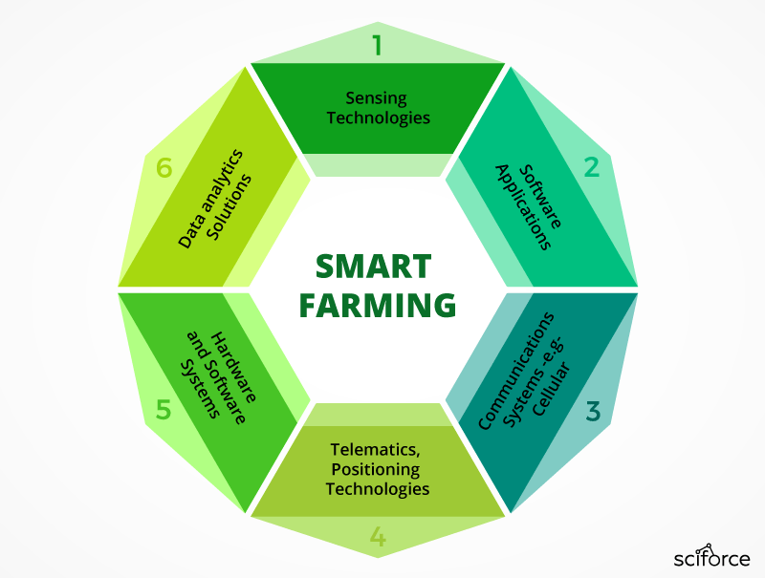

GIT HUB LINK: IBM-EPBL/IBM-Project-31333-1660199397: SmartFarmer - IoT Enabled Smart Farming Application (github.com)

demo video link:smart forming demo vidoe - Create and share your videos with Clipchamp